IFT 266 Introduction to Network Information Communication Technology (ICT)
Lab 21
VLSM (Variable Length Subnet mask)

Question 1

You are setting up a medium sized network with the address 66.66.66.0/24.
Marketing needs 2 computers.
Research and development need 120 computers.
Bookkeeping will use 15 computers.
Reception area will need 5 computers.
Management requires 20 computers.
Divide the network using VLSM.
Subnets are assigned from largest to smallest.
Everything is based on the number of usable hosts.
Complete the information required below.

Subnet | Subnet Mask (/X) | Subnet  Address | First Usable  Host | Broadcast  Address
1 | /25 | 66.66.66.0/25 | 66.66.66.1 | 66.66.66.127
2 | /27 | 66.66.66.128/27 | 66.66.66.129 | 66.66.66.159
3 | /27 | 66.66.66.160/27 | 66.66.66.161 | 66.66.66.191
4 | /29 | 66.66.66.192/29 | 66.66.66.193 | 66.66.66.199
5 | /30 | 66.66.66.200 | 66.66.66.201 | 66.66.66.203

Question 2

A new school is being built in the local school district.
It will have 4 computer labs with 12 computers each.
There will be 2 classrooms with 30 computers in each each.
The office staff and administrators will need 7 computers.
The guidance and attendance office will have 5 computers.
The school has been given the address 10.10.10.0/24.

Subnets are assigned from largest to smallest.
Everything is based on the number of usable hosts.
Complete the information required below.
 | Subnet Mask (/X) | Subnet  Address | First Usable  Host | Last Usable Host | Broadcast  Address
1 | /27 | 10.10.10.0 | 10.10.10.1 | 10.10.10.30 | 10.10.10.31
2 | /27 | 10.10.10.32 | 10.10.10.33 | 10.10.10.62 | 10.10.10.63
3 | /28 | 10.10.10.64 | 10.10.10.65 | 10.10.10.78 | 10.10.10.79
4 | /28 | 10.10.10.80 | 10.10.10.81 | 10.10.10.94 | 10.10.10.95
5 | /28 | 10.10.10.96 | 10.10.10.97 | 10.10.10.110 | 10.10.10.111
6 | /28 | 10.10.10.112 | 10.10.10.113 | 10.10.10.126 | 10.10.10.127
7 | /28 | 10.10.10.128 | 10.10.10.129 | 10.10.10.142 | 10.10.10.143
8 | /29 | 10.10.10.144 | 10.10.10.145 | 10.10.10.150 | 10.10.10.150

Question 3

You are setting up a network for a company in four locations.
Location A has 16 computers.
Location B has 125 computers.
Location C has 14 computers.
Location D has 6 computers.
There is a WAN connection between all four locations.
Complete the information required below using the address 33.33.33.0

Subnets are assigned from largest to smallest.
Everything is based on the number of usable hosts.
Subnet | Subnet Mask (/X) | Subnet  Address | First Usable  Host | Last Usable Host | Broadcast  Address
1 | /25 | 33.33.33.0 | 33.33.33.1 | 33.33.33.126 | 33.33.33.127
2 | /27 | 33.33.33.128 | 33.33.33.129 | 33.33.33.158 | 33.33.33.159
3 | /27 | 33.33.33.160 | 33.33.33.161 | 33.33.33.190 | 33.33.33.191
4 | /29 | 33.33.33.192 | 33.33.33.193 | 33.33.33.198 | 33.33.33.199
5 | /30 | 33.33.33.224 | 33.33.33.225 | 33.33.33.226 | 33.33.33.227
6 | /30 | 33.33.33.228 | 33.33.33.229 | 33.33.33.230 | 33.33.33.231
7 | /30 | 33.33.33.232 | 33.33.33.233 | 33.33.33.234 | 33.33.33.235

Question 4

A small company needs to set up its network across several locations.
The New York branch office needs 60 computers.
The San Jose office needs 62 computers.
The Trinidad office will need 30 computers.
You will need two WAN links between the routers.
Using the IP address 111.111.111.0/24 divide the network using VLSM.

Part A: Complete the information required below.

Subnet | Subnet Mask (/X) | Subnet  Address | First Usable  Host | Last Usable Host | Broadcast  Address
1 | /26 | 111.111.111.0 | 111.111.111.1 | 111.111.111.62 | 111.111.111.63
2 | /26 | 111.111.111.64 | 111.111.111.65 | 111.111.111.126 | 111.111.111.127
3 | /27 | 111.111.111.128 | 111.111.111.129 | 111.111.111.158 | 111.111.111.159
4 | /30 | 111.111.111.192 | 111.111.111.193 | 111.111.111.194 | 111.111.111.195
5 | /30 | 111.111.111.196 | 111.111.111.197 | 111.111.111.198 | 111.111.111.199

Question 5

Create an addressing scheme using VLSM
(Write your answers on/around the image)

Network 6.6.6.0

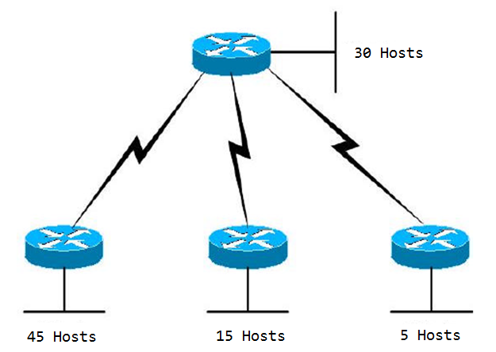

Gentle Reminder

Make sure to include the 3 WAN subnets for this topology.

Hosts | Subnet address | First usable host | Last usable host | Broadcast address
45 | 6.6.6.0/26 | 6.6.6.1 | 6.6.6.62 | 6.6.6.63
30 | 6.6.6.64/27 | 6.6.6.65 | 6.6.6.94 | 6.6.6.95
15 | 6.6.6.96/27 | 6.6.6.97 | 6.6.6.126 | 6.6.6.127
5 | 6.6.6.128/29 | 6.6.6.129 | 6.6.6.134 | 6.6.6.135
WAN-1 | 6.6.6.136/30 | 6.6.6.137 | 6.6.6.138 | 6.6.6.139
WAN-2 | 6.6.6.140/30 | 6.6.6.141 | 6.6.6.142 | 6.6.6.143
WAN-3 | 6.6.6.144/30 | 6.6.6.145 | 6.6.6.146 | 6.6.6.147

